**Test Technique Back-End**

***Petal***

|  |  |
| --- | --- |
| **Author** | **Fabian Torres** |
| **Date:** | **2021-09-28** |

**1. TECHNOLOGIES USED:**

|  |
| --- |
| **SpringBoot Framework V.2.5.5** (Spring Tool Suite 4) |
| **Maven** (Dependency or Artifact Manager in JAVA) |
| **JPA (**Persistence API developed for the Java EE platform**.** It allows me to convert classes to SQL statements and SQL to classes or objects) |
| **JAVA 8** (Programming language) |
| **MySQL 8.0** (Database) |
| **Swagger2** (API Rest documentation) |
| **Application Server** (Apache Tomcat embedded in Spring Boot) |
| **Plugin of Chrome:** JSON Viewer Pro |
| **Plugin of Chrome:** Talend API Tester - Free Edition |

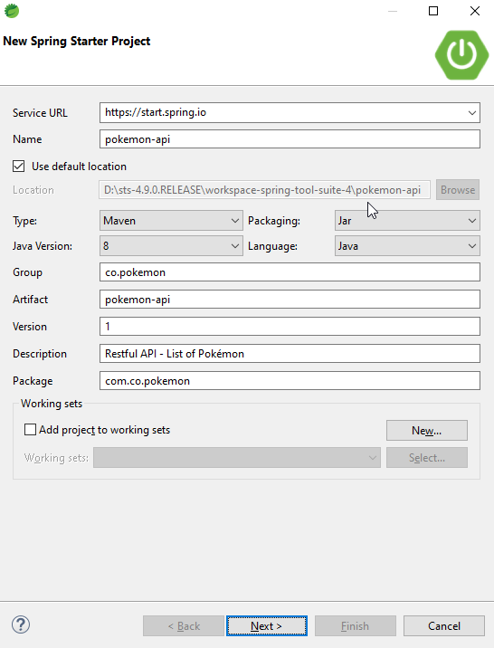

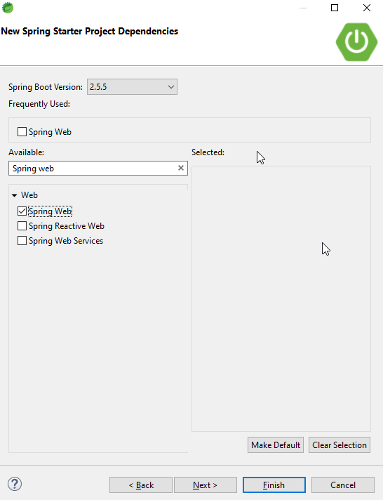

**2. Spring Tool Suite 4: Config of Server port 8090 (Application Server):**

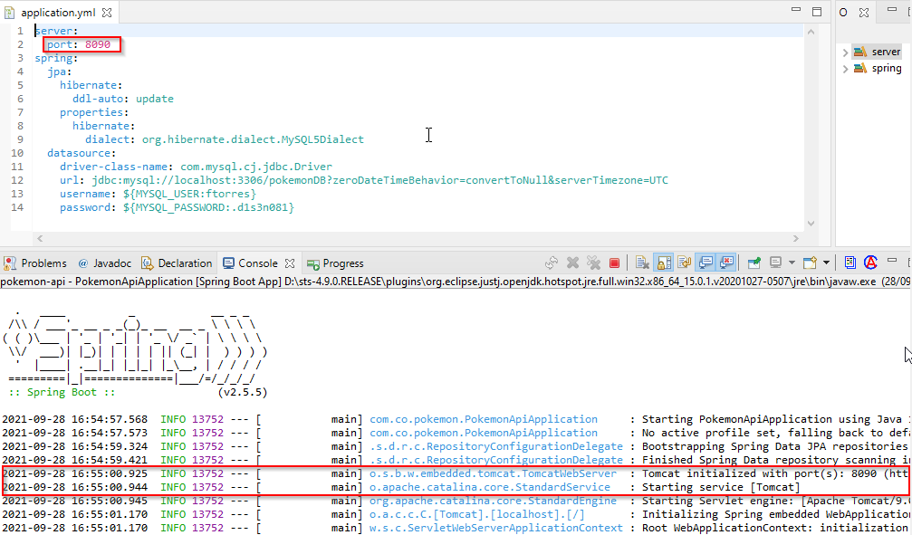

**3. JSON Viewer Pro: (Consumo de Servicio Restful API):**

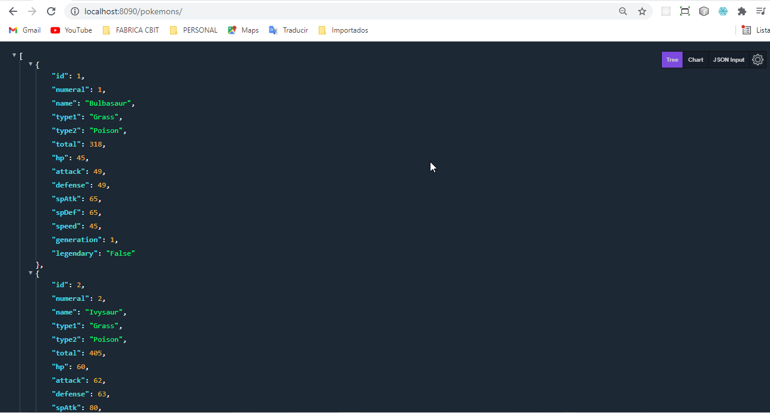

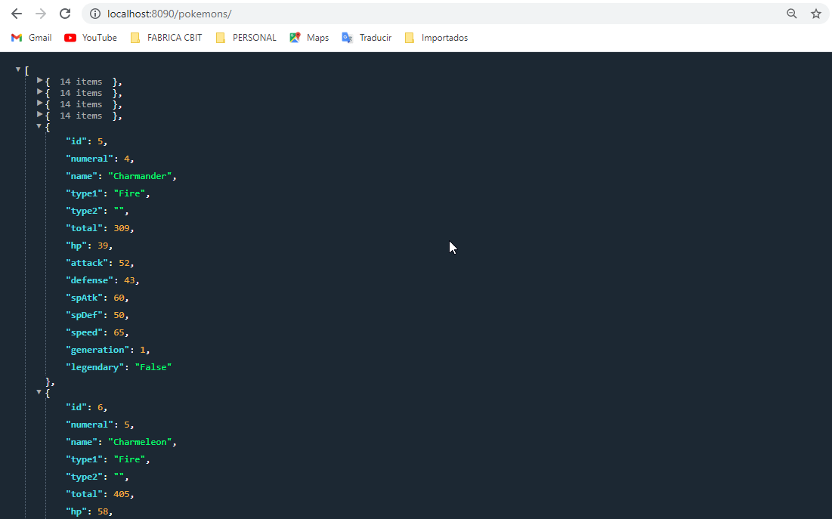

**4. CRUD – Unit Testing in POSTMAN:**

**4.1 Operation GET: List of Pokémons**

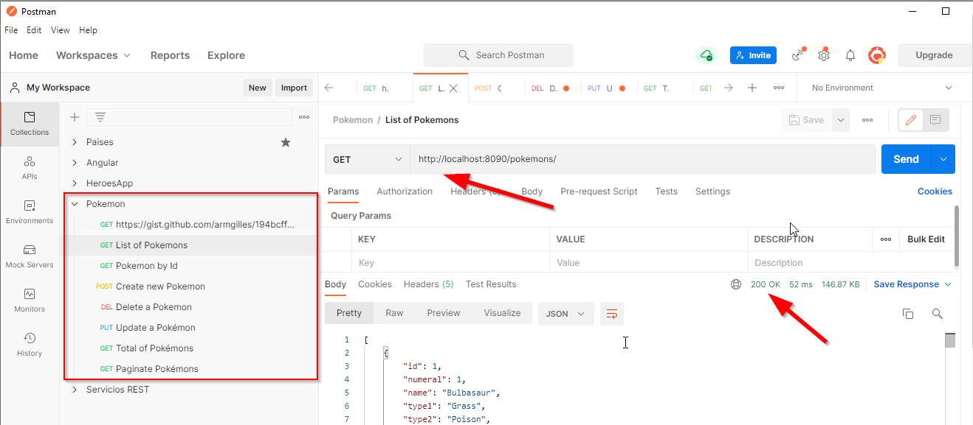

**4.2 Operation GET: Pokémon By Id**

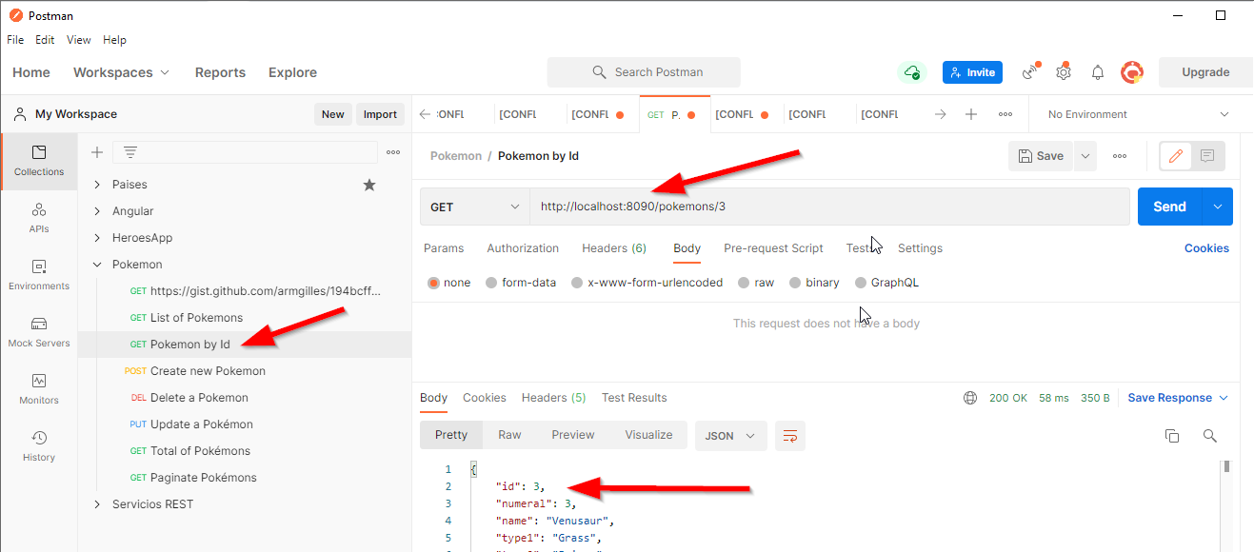

**4.3 Operation POST: Create new Pokémon**

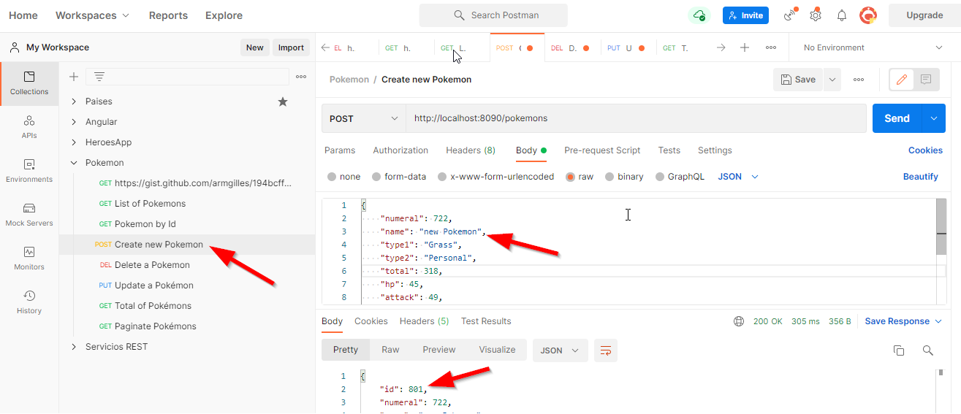

**4.3.1 New record in Database MySQL**

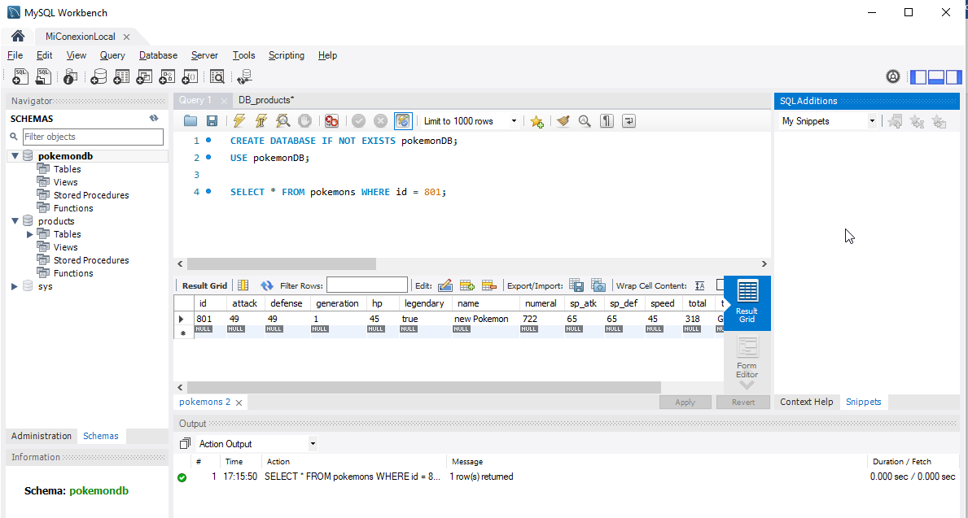

**4.4 Operation PUT: Modify a Pokémon**

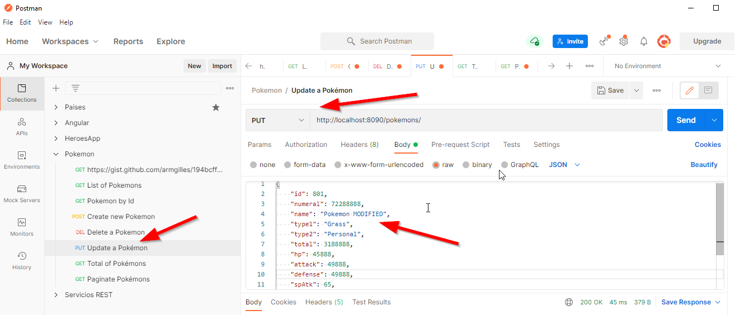

**4.4.1 Record updated in Database MySQL**

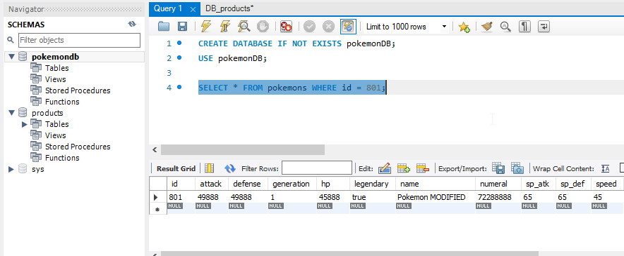

**4.5 Operation DELETE: Delete a Pokémon**

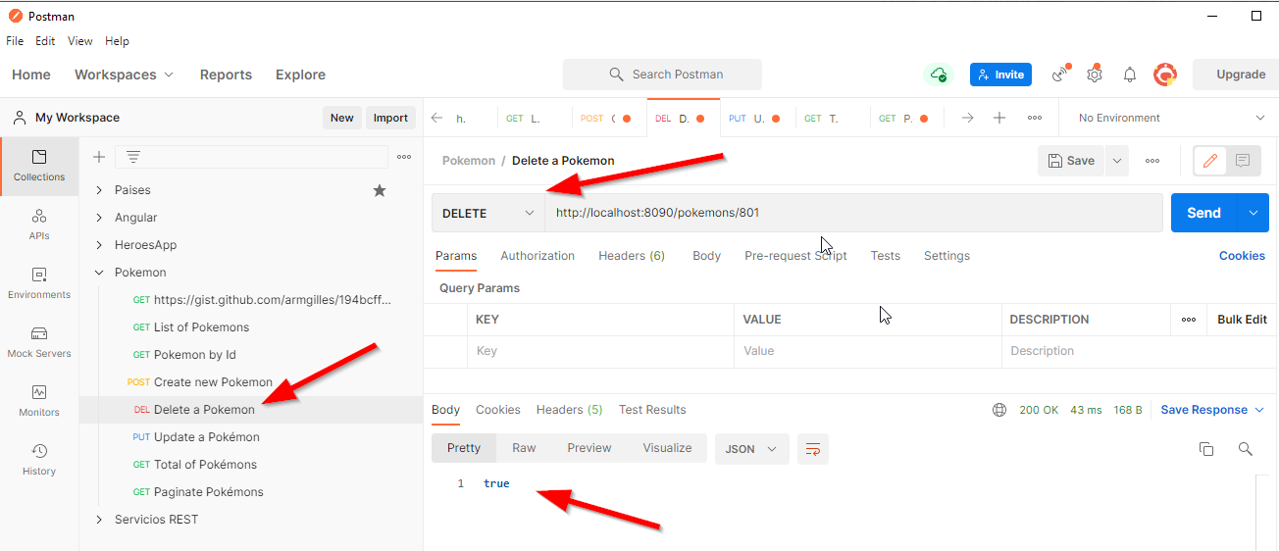

**4.5.1 Record updated in Database MySQL**

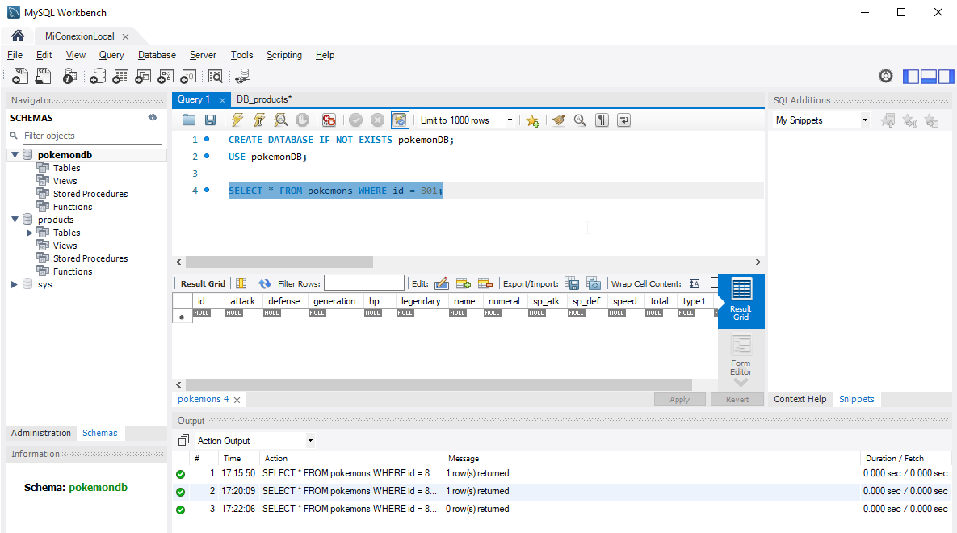

**4.6 Operation GET: Total de Pokémons (File CSV)**

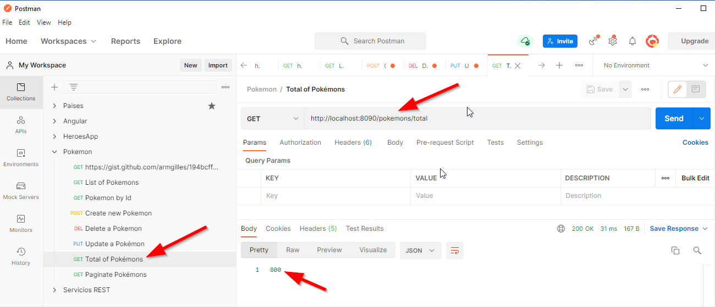

**4.7 A paginated list of all Pokémon in the file:**

@RequestMapping(value="paginate/{page}-{size}", method = RequestMethod.***GET***)

**Get 10 records of page 1**

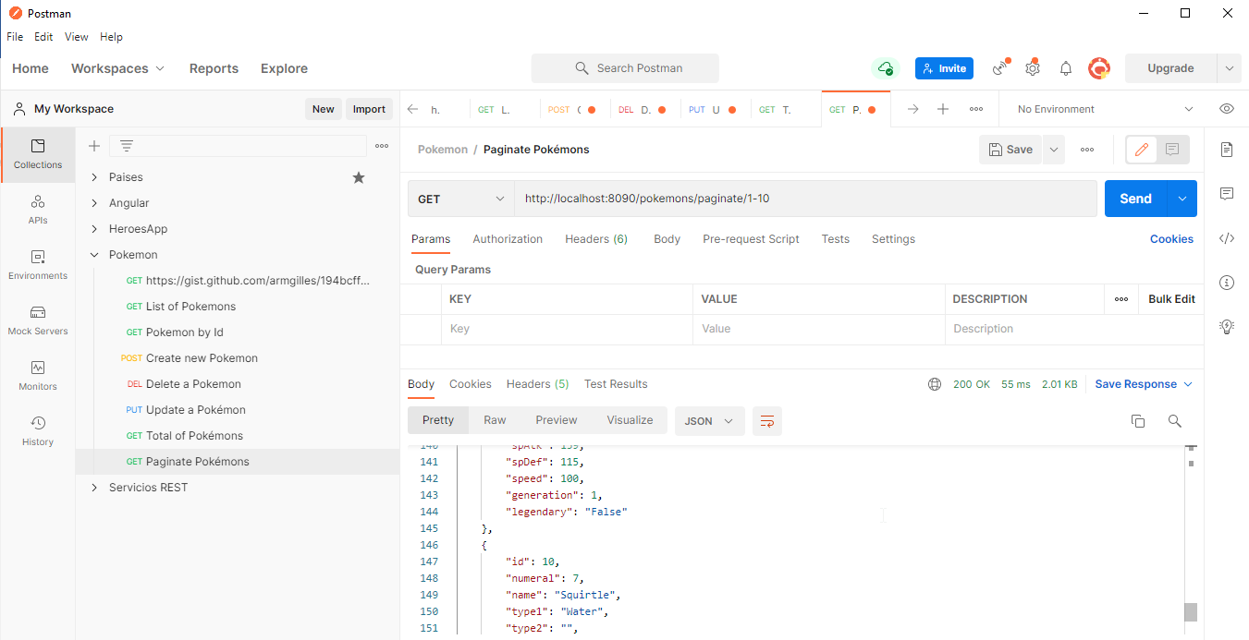

**Get 10 records of page 2 ( start 11 to 20 )**

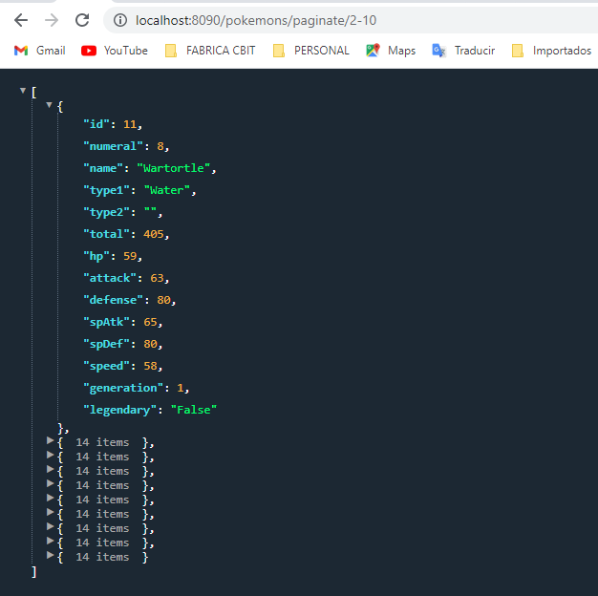

**5. Swagger2 (API Rest documentation)**

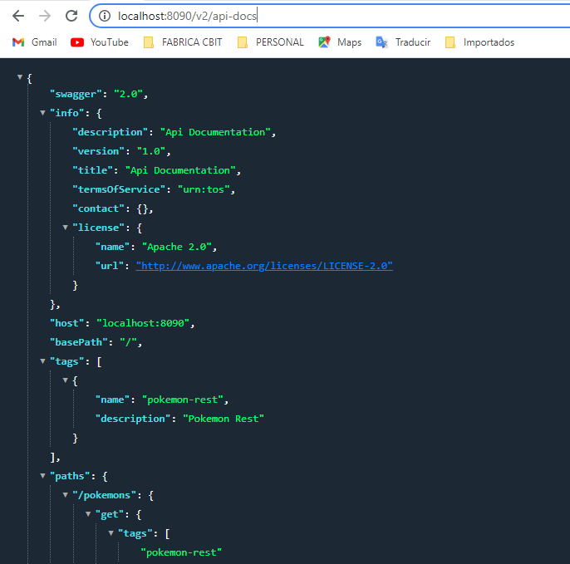

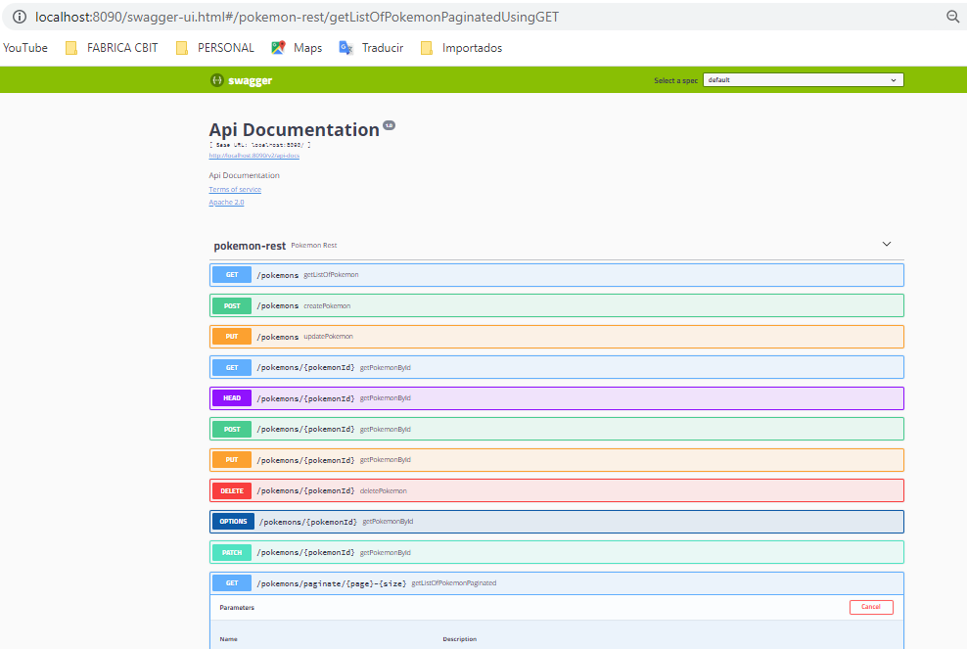

**Test Unit**

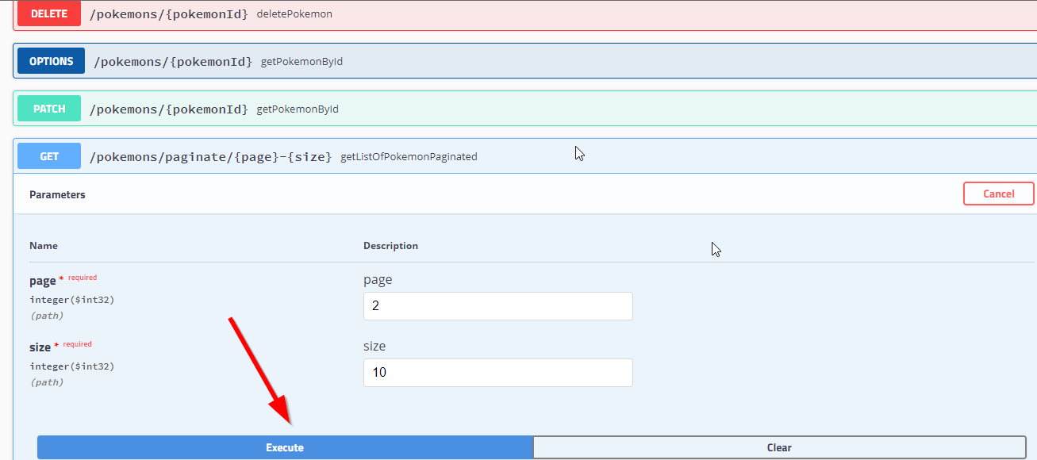

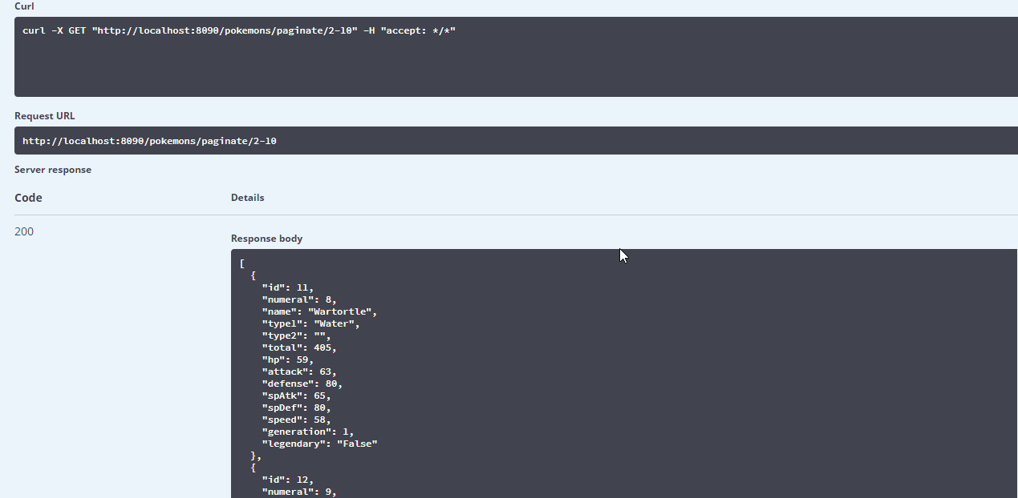

**6. DATABASE MYSQL 8.0**

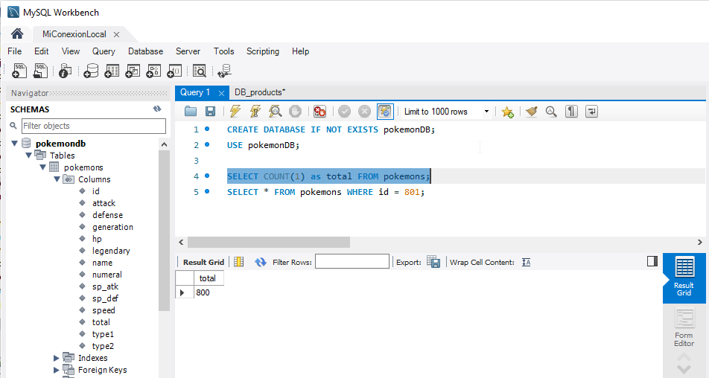

**7. File Pokémon (CSV)**

**Here is the link for the CSV file:**

[**https://gist.github.com/armgilles/194bcff35001e7eb53a2a8b441e8b2c6**](https://gist.github.com/armgilles/194bcff35001e7eb53a2a8b441e8b2c6)

**8. OTHERS PLUGINS**

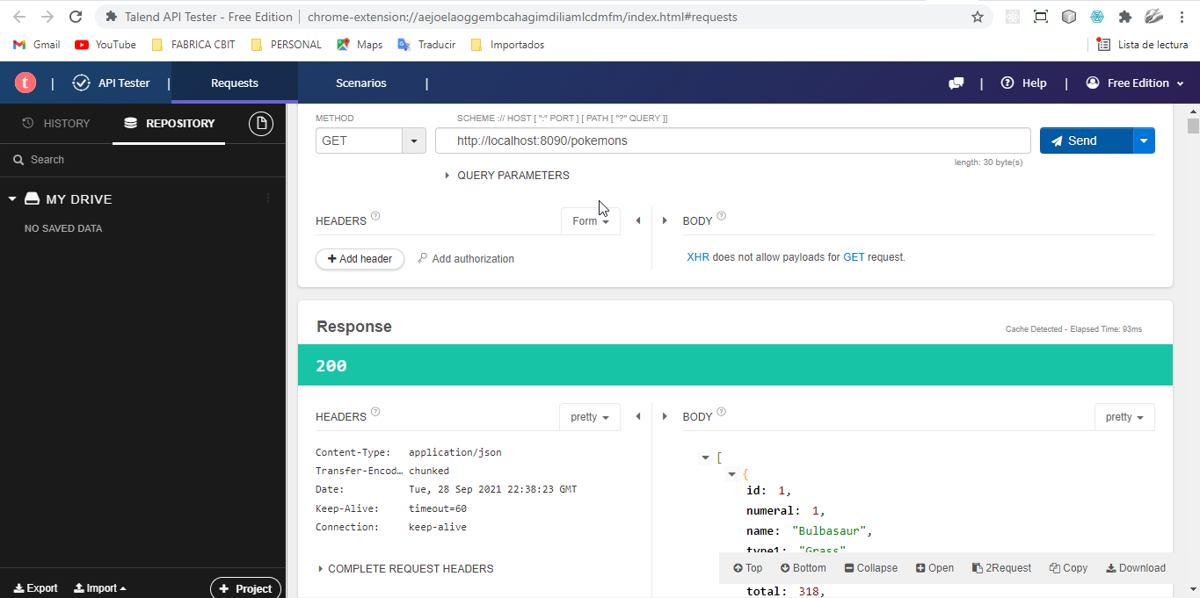

**9. JUnit 4 – Test Unit**

